Logging and security features in OL Monitor

1. Logfiles:
Ol Monitor has a single dedicated text file that it logs its various activities to. The logfile is located in the same folder that it stores the captured OL or PL (overdue log/pending log) files. The dedicated process logfile will always be name 'OLProcessLog.txt'. This file is separate from the captured Pending/Overdue logfiles, they will be named 'Test.tx1, Test.tx2..., Text.tx10' or 'PLTest.tx1, PLTest.tx2..., PLTest.tx10'. Under Windows XP the logfile(s) folder will be the Smarterm 'Sessions' folder, usually:
C:\Documents and Settings\USER\My Documents\SmarTerm\Sessions
There may be an install option in Smarterm to have Smarterm use the 'All Users' folder instead of 'My Documents'. If this is the case OL Monitor will use the All Users folders also.
Under Windows 7 the folder will be:
C:\Users\Public\Documents\OlMonitor
In Windows 7 Ol Monitor attempts to store all of its working files in this one folder. However in some cases Smarterm does not allow us to change the Sessions folder, so the captured logfiles may be stored in:
C:\Users\USER\Documents\Smarterm\Sessions or:
C:\Users\Public\Documents\Smarterm\Sessions
There is a complete list of all working file paths online here:
http://olmonitor.com/Home/Support#FilesTablenProblems
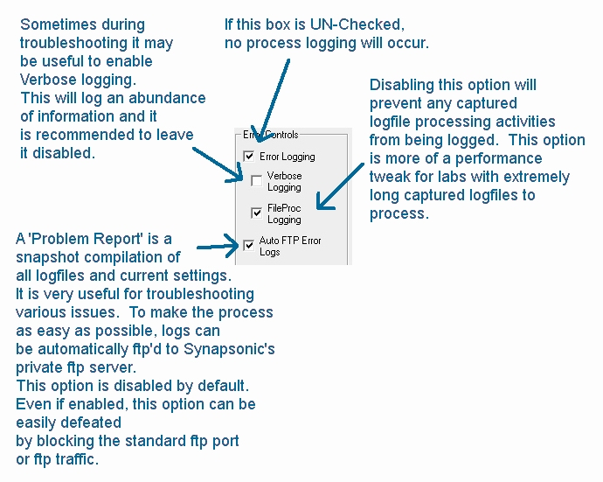
2. Logging options:
A few options control what is logged to the process logfile and how. It is also possible to turn the logfile off completely.
These options are under the 'Misc' tab of Ol Monitor options.

-Encryption options under 'Advanced' tab in options:
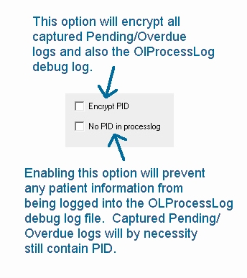

4. Login and password / Sunquest connection:
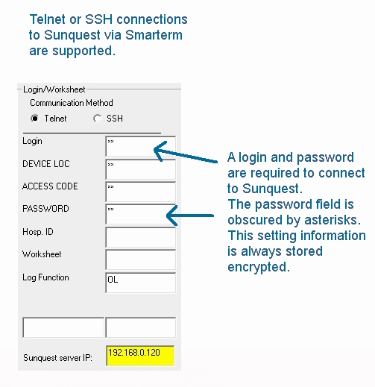
Settings can be protected with a password:
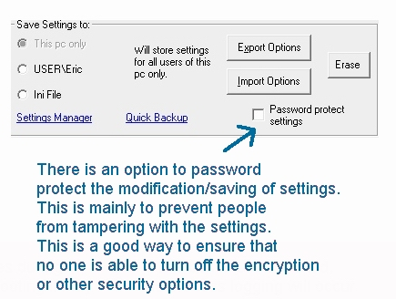
Helpful links:
Online Manual: http://www.olmonitor.com/ManualM/index.htm
Troubleshooting http://olmonitor.com/Home/Support
Ol Monitor Blog (special issues/installing/etc.): http://olmonitor.com/blog/

